1. Setup guide:
2. Install ‘nvm’ for Mac: Follow [this link](https://www.youtube.com/watch?v=ohBFbA0O6hs)
3. After installing ‘nvm’, open Command Prompt and install NodeJS version 12.16.3 with this command:

**nvm install 12.16.3**

1. Use this command to choose NodeJS v.12.16.3 to run the bot:

**nvm use 12.16.3**

1. Set up sub-provider (for your wallet payment) via infura:

* Visit: <https://infura.io/>
* Sign Up using your own email
* After signing up and logging into your account in Infura Dashboard, click “Create new Project”

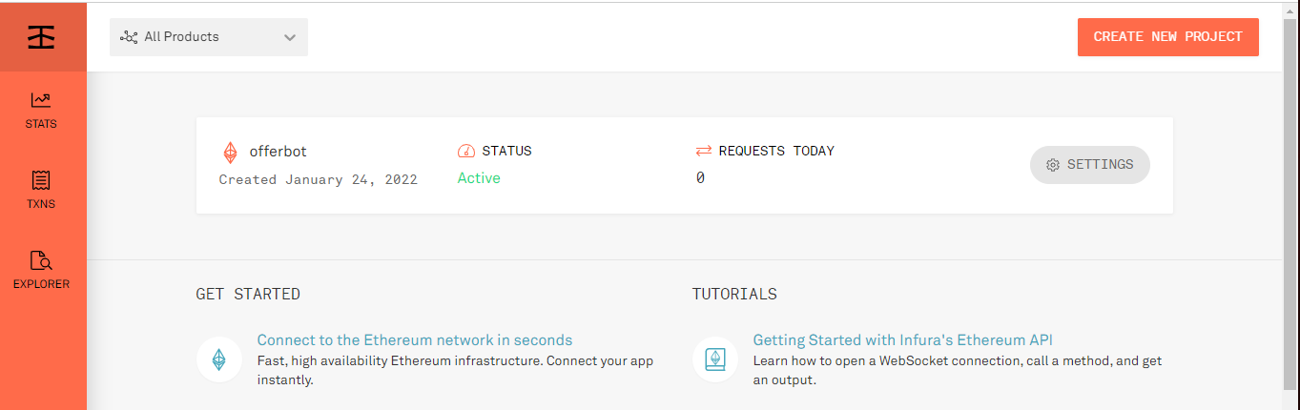

* In Product drop down, choose “Ethereum”. Set a name for your project, and then click “Create”

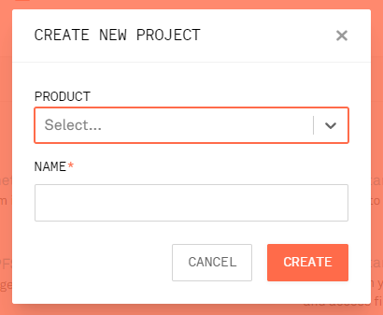

* You’ll be navigated to the Project settings after this, here, scroll down to the ENDPOINTS part. Remember to leave the ENDPOINTS option as MAINNET, then copy the <https://...> Line and save it to a safe place for later use.

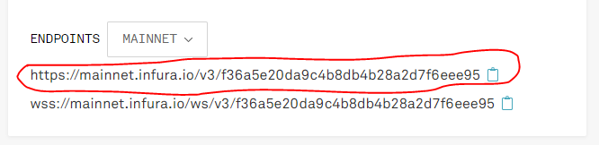

1. Request an OpenSea API key:

* Submit the form here: <https://docs.opensea.io/reference/request-an-api-key>
* After 2 – 3 days you will be given with an API key from OpenSea Team. Save it to a safe place for later use

1. Export your Wallet private key:

* Open Metamask extension on your browser, click on the 3-dot icon on the right

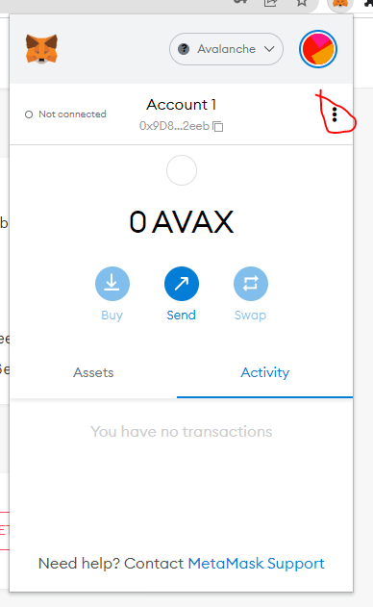

* Choose “Account details”

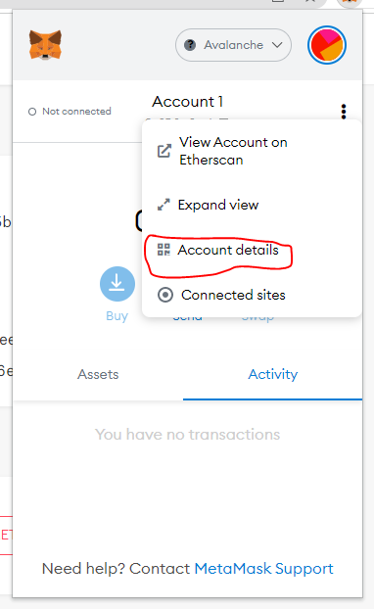

* Choose “Export your private key”

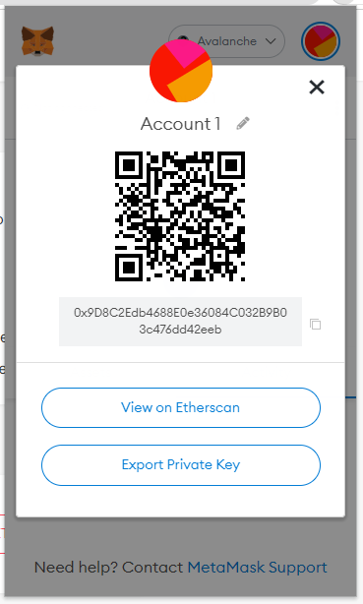

* Then save the Private key to a safe place for later use

1. Prepare ‘.env’ file

* Extract the project folder (os-buy-bot folder)
* Open the ‘.env’ file in text editor mode (Open as TextEdit), if this file is hidden, follow this instruction to make it visible again: <https://ianlunn.co.uk/articles/quickly-showhide-hidden-files-mac-os-x-mavericks>

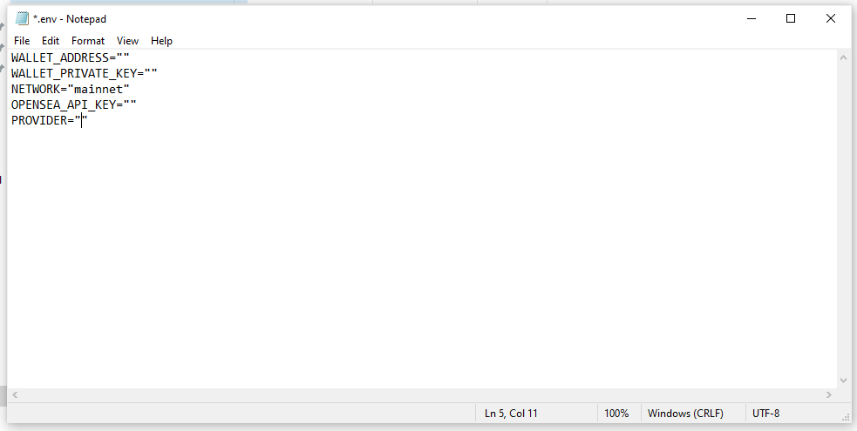

* Here fill inside the double quote these values and SAVE the file:
  + WALLET_ADDRESS = “<Your wallet address>”
  + WALLET_PRIVATE_KEY = “<Your wallet private key – which was got from step 1f>”
  + NETWORK = “mainnet”
  + OPENSEA_API_KEY = “<The API key you got from 1e>”
  + PROVIDER=”<The URL you copied from 1d>”
* For examples (here is just fake input):

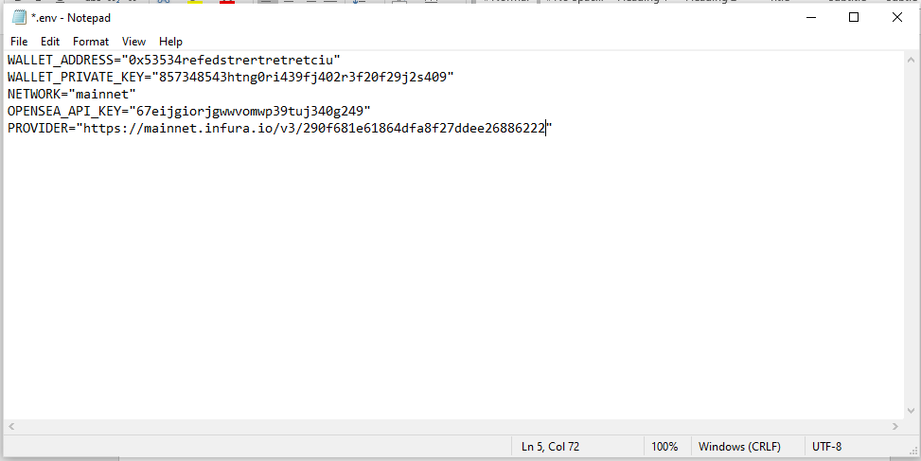

1. Run the bot:
   1. Set the expiration for the offers in epoch format
      1. Go to <https://epochconverter.com>
      2. Set the end time for your offer, and then click on “Human date to timestamp”

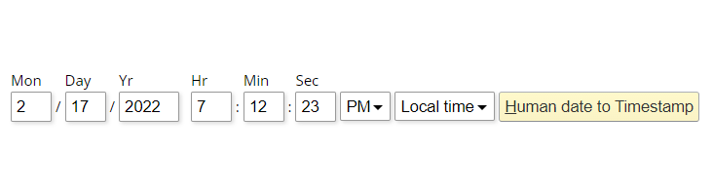

* + 1. Copy the generated timestamp and save it for later use

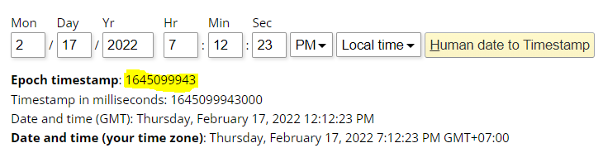

* 1. Get the collection slug

Collection slug of the collection you want to make offer on (for example: the URL format of "Monkeverse" collection is "https://opensea.io/collection/monkeverse" --> slug is "monkeverse"

* 1. Open Terminal
  2. Navigating to the project folder (the os-buy-bot folder) using “cd” command
  + You can learn more [here](https://www.macworld.com/article/221277/command-line-navigating-files-folders-mac-terminal.html)
  1. Then run the bot with this command:

**node offer.js --offerPrice=<input offer price in ETH> --slug=<"input collection slug"> --timeOut=<end time of the offer in epoch format in 2a(iii)>**

For example:

**node offer.js --offerPrice=0.001 --slug="mokeverse" --timeOut=1645099943**

**Hit “ENTER” or “RETURN” to start running the bot**

**Enjoy!**

**node offer.js --offerPrice=0.000000001 --slug=“livesofasuna" --timeOut=1645597648**

**node offer.js --offerPrice=0.000000001 --slug=“monkeverse" --timeOut=1645597648**

**node offer.js --offerPrice=0.000000001 --slug=“azuki" --timeOut=1645597648**